Hong Kong’s illegal ivory hub status ‘could grow after planned mainland China ban’ SCMP

Sellers could use gap before city’s planned 2021 phase-out to launder illegal stocks, environmentalists warn

PUBLISHED : Saturday, 31 December, 2016, 6:53pm

UPDATED : Sunday, 01 January, 2017, 11:59am

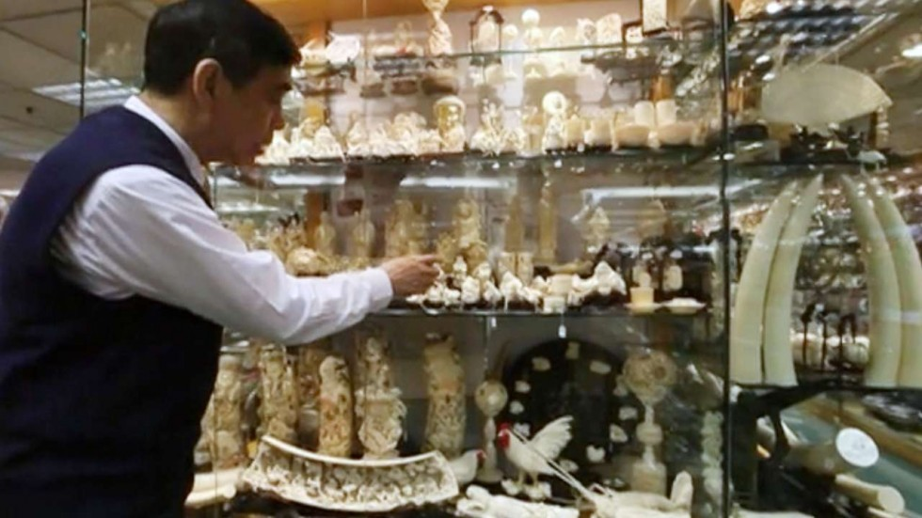

Some 70 tonnes of legal ivory is still on the market. Photo: Handout

Approval for Hong Kong plan to ban ivory trade by 2021

21 Dec 2016

Wildlife campaigners have urged Hong Kong authorities to fast-track the phasing out of the city’s ivory trade, warning of a surge in illegal business after the mainland announced a total ban within a year.

WWF Hong Kong yesterday contrasted Beijing’s quick action with the city’s plan to end the controversial trade in five years, which effectively allows traders a grace period until 2021.

The group’s senior wildlife crime officer, Cheryl Lo, called on the local government to act swiftly, given that Hong Kong is an important transit hub for illegal ivory supplies to the mainland and other parts of Asia.

While hailing China’s “determination to help save Africa’s elephants from extinction”, Lo warned that in the four-year window between the mainland ban and Hong Kong catching up, Chinese sellers could move stocks across the border for sale in the city. But she said the recent news was still cause for optimism.

“With China’s announcement, now three of the world’s largest domestic ivory markets – that is China, Hong Kong and the US – are being phased out.”

Watch: China to ban ivory trade by end of 2017

Late on Friday, Beijing announced plans to shut down its ivory trade by the end of 2017 in a move designed to curb the mass slaughter of African elephants.

The mainland will end the processing and sale of ivory and ivory products by the end of March, according to a statement.

Earlier this month, the Hong Kong government announced a three-step plan to phase out the local ivory trade by the end of 2021, with a proposal to go before the legislature in the first half of next year.

But local ivory sellers said a ban within five years was unfair to licensed traders who must sell off the remainder of their legal stock.

The city still has some 70 tonnes of legal ivory on the market out of the original 700 tonnes registered when a 1989 ban on international trade came into effect.

Hong Kong has lots of legal ivory shops.

So Chi-keung, president of the Hong Kong and Kowloon Ivory Manufacturers Association, said most of those stocks were large, ornate and expensive carvings that were hard to sell.

“How did they calculate that we will be able to sell all our stock in five years?” he said.

Aili Kang, Asia director for the New York-based Wildlife Conservation Society, said the mainland’s latest decision was a game changer for Africa’s elephants.

“President Xi Jinping announced last year that China would take this action, and now we have a timeline. This is great news that will shut down the world’s largest market for elephant ivory,” Kang said.

“We call on all other countries with legal domestic ivory markets to follow China’s lead and close their markets as well.”

31 Dec 2016

Related Articles

[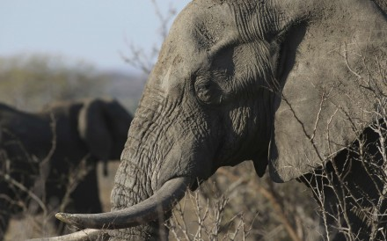](http://www.scmp.com/news/china/article/2058349/china-vows-shut-down-ivory-trade-end-2017)

[**China**](http://www.scmp.com/news/china)

[China pledges to end its ivory trade in 2017](http://www.scmp.com/news/china/article/2058349/china-vows-shut-down-ivory-trade-end-2017)

31 Dec 2016

[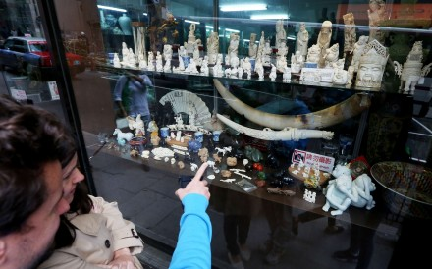](http://www.scmp.com/news/hong-kong/health-environment/article/2057272/hong-kong-ivory-traders-mull-legal-challenge)

[**Health & Environment**](http://www.scmp.com/news/hong-kong/health-environment)

[Ivory traders mull legal challenge against sale ban](http://www.scmp.com/news/hong-kong/health-environment/article/2057272/hong-kong-ivory-traders-mull-legal-challenge)

26 Dec 2016

[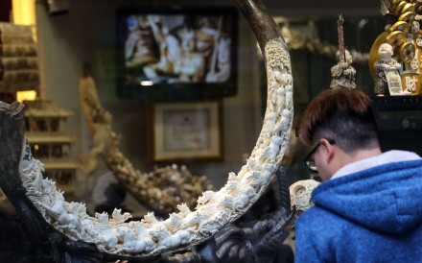](http://www.scmp.com/news/hong-kong/health-environment/article/2056411/hong-kong-plan-ban-ivory-trade-2021-receives)